# **Abstract**

Facial recognition technology has seen significant progress in recent years and offers a transformative impact on various industries. This article provides a comprehensive overview of the methodologies used in developing an effective face recognition system. Starting with the critical step of loading the dataset, the study explores the use of preprocessing and data augmentation techniques to increase the suitability of images for training a machine learning model. Feature extraction, performed through convolutional neural networks (CNN) and MobileNetV2 transfer learning, plays a key role in transforming raw image data into manageable and representative features. The research will delve into the learning curves of these models and shed light on their adaptive dynamics during training. Splitting the data using the train_test_split function ensures a clear delineation of the training and test datasets. The evaluation phase uses key metrics such as accuracy, precision, and F1 score, which shows that the Random Forest model is the most efficient among the evaluated models. Ethical, legal, and security considerations are taken into account to ensure responsible deployment. This study offers a robust methodology for the development of accurate and reliable facial recognition systems, contributing to the evolving landscape of biometric technologies.

**ACKNOWLEDGMENTS**

First and foremost, we want to thank God for guiding us through all the challenges. Every day, we have benefitted from your direction. We were only able to complete our degree thanks to you. We want to appreciate and express our sincere gratitude to our project manager, who made this effort possible. He guided and advised us the entire time, which helped us get our project written through all of its stages.

Additionally, we would like to thank our supportive parents and friends for their assistance and words of encouragement.

Contents

**Abstract** 1

**Part 1 – Reflective CPD** 6

**Self-reflection** 6

**Individual SWOT Analysis** 6

**Strengths:** 6

**Weaknesses:** 7

**Research:** 8

**Threats:** 8

**Summary:** 8

**Part 2 – Research Proposal** 9

Chapter 1 9

**1.1 Background** 10

**1.2 Aims:** 11

**1.3** **Research Questions:** 11

**1.4 Objective** 12

**1.3** **Research scope:** 12

**Chapter 2** 13

**Literature Review** 13

**Chapter 3** 17

**3.1 Research Methodology** 17

**3.1 Dataset:** 17

**3.2 System Implementation** 21

**3.2.1 System Design Representation** 21

**3.2.2** 25

**3.2.3 Research Plan and Task Lists** 25

**Chapter 4** 31

**EVALUATIONS** 31

**Code:** 31

**Code Setup:** 31

**Code Design/Details:** 31

**Load Dataset:** 32

**Augmenting Data and Preprocessing** 33

34

**Feature Extraction:** 35

**Convolutional Neural Networks (CNNs):** 35

**CNN Model Learning Curve:** 36

**Mobile – Net Transfer Learning** 37

**Mobile – Net Learning Curve:** 37

**Data Splitting:** 38

**Random Forest:** 42

**Support Vector Machine:** 43

**K Nearest Neighbor:** 43

**Results and Findings:** 45

**Performance Validation:** 45

**Risk Assessment and Management** 46

**Chapter 5** 48

**5.1 Conclusion** 48

**5.2 Ethics, Legal, Social, Security and Professional Consideration** 49

References 52

**List of Figure:**

Figure 3.1 Dataset 18

Figure 3. 2 Methodology 21

Figure 3.3 System Design 22

Figure 3.4 Import Libraries 31

Figure 3 5 Load Dataset 32

Figure 3.6 Preprocessing 33

Figure 3. 7 Image Augmentation 33

Figure 3. 8 CNN Model 34

Figure 3.9 CNN Model Learning Curve: 35

Figure 3.10 Mobile - NET 36

Figure 3. 11 Mobile – Net Learning Curve 37

Figure 3. 12 Split Data 38

Figure 3. 13 Random Forest 41

Figure 3.14 SVM 42

Figure 3.15 KNN 43

Figure 3.16 MLP 44

# **Part 1 – Reflective CPD**

## **Self-reflection**

I'm [name], and I'm presently studying at the University of Northumbria in London for an MSc in Big Data and Data Science Technology. I started my academic career by concentrating on computer science at the bachelor's and master's levels, with a particular emphasis on courses linked to programming. My decision to pursue a Diploma in Internet of Things was a turning point that piqued my interest in data science. My love for programming was stoked by working with Google Cloud, MySQL, and programming languages like C, CPP, JAVA, and Python. Getting the MSc will give me a thorough understanding of data science, cloud-based systems, and machine learning, which is a big step in my development as a data analyst/scientist. My career goals are in line with the curriculum, which gives me the highly sought-after skills for a variety of IT industry roles. I use a research development plan and a personal SWOT analysis because I understand how important it is to reflect on oneself. In order to address biases and limitations and make a valuable contribution to this quickly expanding field, my dissertation investigates facial recognition using federated learning.

# **Individual SWOT Analysis**

It is important to emphasize that the study will use federated learning as its methodology in order to create an efficient model for face recognition and identification. The primary goal is to assess the system's performance in accurately identifying individual faces. This evaluation includes comparisons with established models that have demonstrated success in face recognition and are widely accepted. In addition, the study seeks to uncover new insights through the federated learning model and evaluate its effectiveness and feasibility in real-world scenarios. The ultimate goal is to design a robust model that will contribute to the advancement of facial recognition technology.

## **Strengths:**

**Personal:**

Proficient in deciphering intricate medical data and extracting meaningful insights. Possess a solid grasp of the foundational principles of machine learning and image processing. Demonstrate technical expertise in Python coding and proficiency with platforms such as Tableau, Google Cloud, and AWS. Additionally, bring hands-on experience in data testing and cleaning processes. In the realm of research, facial recognition utilizing federated learning showcases notable strengths. It achieves heightened accuracy and reliability while prioritizing privacy by maintaining data locally on individual devices. This approach attains comparable accuracy to centralized methods but distinguishes itself with a remarkable 99.6% reduction in data transmission. The facial recognition industry is expected to grow at a strong 14.5% Compound Annual Growth Rate (CAGR) between 2021 and 2028. One important trend that is helping to address privacy concerns is federated learning.

## **Weaknesses:**

**Personal:**

As for research, despite the promise held by facial recognition using federated learning, it is not exempt from weaknesses. Vulnerabilities include susceptibility to errors and biases originating from factors like plastic surgery, lighting conditions, or makeup. According to a study published in Nature Communications, having plastic surgery can result in a significant drop in facial recognition system accuracy of up to 20 times. Moreover, darker skin tones may experience up to a 100-fold increase in error rates. Federated learning, however, continues to be able to achieve high accuracy while maintaining privacy, making it a significant trend in addressing privacy concerns in the ever-changing facial recognition market.

**Opportunity:**

**Personal:**

Participating in workshops and conferences provides a priceless opportunity to increase one's knowledge and proficiency in the field of choice. The learning curve is accelerated when one is exposed to a variety of theories, approaches, techniques, and technologies that are relevant to creating, improving, and testing data science applications for business intelligence. Specifically exciting is the chance to work with TensorFlow machine learning technology and train and deploy distributed machine learning modules using cloud-based infrastructures such as Microsoft Azure, AWS, or Google Cloud. This practical experience fosters critical evaluation of implementation and offers forward-looking recommendations by enabling the practical application of learned knowledge and skills. Understanding the critical roles that cybersecurity and information governance play adds a level of comprehension to the adoption and use of computer technology in diverse business and organizational settings.

## **Research:**

Federated learning in facial recognition technology opens up a plethora of opportunities across diverse industries, including banking, healthcare, law enforcement, marketing, and retail. Its practical applications span emotion recognition, identification, surveillance, and authentication. Recent studies suggest that the implementation of federated learning could result in enhanced patient identification, reduced medical errors, and personalized customer experiences, streamlining checkout processes and improving product recommendations. A recent analysis published in the Journal of Business Research delved into the application of facial recognition technology in the retail sector. The findings highlight the potential for a significant enhancement in the retail customer experience through personalized product recommendations, streamlined checkout procedures, and optimized inventory control. These insights underscore the transformative power of facial recognition technology and federated learning, heralding a revolution in the retail industry and paving the way for more efficient and personalized shopping experiences for customers.

## **Threats:**

The adoption of facial recognition through federated learning introduces nuanced challenges that merit in-depth consideration. A critical concern revolves around the potential biases entrenched within the datasets utilized for model training. These biases, if not meticulously addressed, can lead to the production of inaccurate and unjust outcomes, raising profound social and ethical questions. Furthermore, the deployment of facial recognition technology for espionage purposes raises apprehensions regarding privacy breaches and the potential for abuses of power. This scrutiny has prompted valid criticism from advocacy groups and underscores the need for robust safeguards to preserve individual rights and privacy. An exhaustive report from the American Civil Liberties Union (ACLU) delves into the intricate challenges associated with deploying facial recognition for surveillance objectives. The research highlights a troubling trend where facial recognition technology is frequently wielded to target and monitor individuals based on characteristics such as race, religion, and political affiliations. This unsettling reality gives rise to substantial concerns surrounding privacy and civil rights, emphasizing the imperative for ethical considerations and policy frameworks.

# 

# **Summary:**

In navigating the landscape of facial recognition through federated learning, it becomes evident that the technology carries both promises and perils. The strengths lie in its potential to revolutionize security measures and reshape access control systems across various sectors. However, the journey is fraught with challenges, with biases in training datasets posing a risk of unjust outcomes. Moreover, the application of facial recognition in surveillance raises profound concerns about privacy breaches and the misuse of power. A closer examination of the threats reveals that biases within datasets demand meticulous attention to prevent unintended consequences. The potential for privacy breaches and power abuses adds layers of complexity that require robust safeguards. Drawing insights from a comprehensive report by the American Civil Liberties Union (ACLU), it becomes clear that facial recognition technology is not immune to targeting individuals based on sensitive attributes, amplifying concerns about privacy and civil rights. In essence, while the opportunities to enhance security and drive transformative changes are compelling, the ethical imperative cannot be overstated. Striking a balance involves addressing concerns related to privacy, bias, and discrimination, ensuring that technological progress is not only efficient but also just and inclusive. The transformative potential of facial recognition through federated learning hinges on navigating these challenges with a commitment to ethical development and responsible implementation.

# **Part 2 – Research Proposal**

# Chapter 1

* 1. **Introduction:**

Face popularity has evolved as a focus point for investigation and innovation in the ever-changing landscape of generation. Professionals from multiple fields, including laptop images, biometrics, sample identification, laptop vision, and machine learning, have come together to describe, create, and analyze this revolutionary period. The tremendous acceptance of face popularity has spread outside the teaching industry and caught the interest of the forensic, commercial, and protection sectors. The allure of face repute goes beyond the boundaries of engineering and time to domains such as neurology, where its ability to facilitate programs ranging from steady speech to computerized access to control systems is often described. Face detection is a crucial first step in automated identification, and it forms the basis of the larger face recognition framework. Face detection is deeply entwined with a number of complex topics, including privacy protection, data security, user device vulnerabilities, the Internet of Things (IoT) landscape, data security expertise, security framework design, and the use of blockchain to improve IoT security. This thorough approach emphasizes the critical role that facial recognition technology plays in the development of technology as well as its significant influence on the state of security and privacy in our increasingly interconnected world. The availability of large datasets for model training, the effectiveness of deep learning, and the unrelenting advancements in artificial intelligence are some of the factors contributing to the quick development of facial recognition technology. These elements have increased face detection accuracy and dependability while also highlighting the growing ubiquity of these technologies in our daily lives. Their uses demonstrate the revolutionary impact of facial recognition on our contemporary society, from streamlining the process of unlocking personal gadgets to augmenting security at airports and public areas. We may unlock the potential for even greater improvements in face recognition technology as we continue to explore the domains of investigation, definition, design, evaluation, and contribution. This will clear the way for a future in which the impacts and applications of face recognition technology will continue to shape and evolve our world.

# **1.1 Background**

The development of facial recognition technology, including the investigation, evaluation, development, and assessment of many methodologies, has been nothing short of extraordinary. It has moved from more basic 2D techniques to more sophisticated 3D and deep learning-based systems. These days, it is widely applied in real-world scenarios, making a substantial contribution to security, access control, and marketing plans. But serious worries about biases and errors that facial recognition systems frequently make have clouded this amazing journey. These problems are particularly noticeable when these systems are required to identify people from different ethnic and cultural backgrounds, which emphasizes the significance of assessment and correction. Due to the increased error rates caused by these biases, there may be cases of injustice and discrimination, which disproportionately harm people with darker skin tones. Another pressing issue that necessitates examination is the impact of plastic surgery on the accuracy of facial recognition systems. If more people choose to change their appearance, the technology's design and functionality may be jeopardized. This may lead to false positives and false negatives, necessitating creative methods to limit the damage. Federated learning, a cutting-edge machine learning method, shows promise in helping to overcome these obstacles. This method eliminates the need for centralized data on a single server by using locally stored data on gadgets like laptops and smartphones to train machine learning models. Because of the decentralized system's design, there is a far lower chance of data breaches and cyberattacks because sensitive data is securely stored on user devices. Federated learning not only tackles these urgent problems but also has promise for enhancing the accuracy and dependability of existing facial recognition systems. Machine learning algorithms can produce more accurate and reliable models by leveraging large and varied datasets that are obtained from many devices. This novel method contributes to a new era of face recognition technology that lessens biases and accuracy issues while protecting user data privacy. It also presents a viable option for future machine learning research.

# **1.2 Aims:**

There are two primary aims for the study of facial recognition technologies. It first aims to comprehend the progression of deep learning and 2D to 3D models in technology. Secondly, it assesses and resolves design problems, including biases arising from diverse backgrounds. With an emphasis on privacy, Internet of Things integration, and data security education, the primary goal is to optimize facial recognition's potential while maintaining data security, fairness, and accuracy for consumers.

# **Research Questions:**

1. How might facial recognition technology be used in the future to investigate and correct biases and mistakes, particularly when identifying individuals from various racial and cultural backgrounds?
2. What are the best strategies for defining and improving the accuracy and fairness of facial recognition systems in order to decrease vulnerabilities for device users?
3. What role does federate learning play in the context of facial recognition technology when it comes to privacy and data security concerns, and how can it help create better solutions?
4. What are the best approaches to employ facial recognition technology in the development and application of Internet of Things (IoT) devices to enhance their security and access control while safeguarding user privacy?
5. Which face recognition libraries and algorithms perform best in real-time applications, and what can be done to assess and improve their effectiveness?
6. What methods may be used to increase facial recognition accuracy when faced with difficult circumstances, like dimly lit rooms or partially obscured faces?
7. How may methods like privacy or differential privacy be used to solve privacy concerns in face recognition systems?

# **1.4 Objective**

1. To investigate and resolve facial recognition software's biases for a range of ethnic and cultural identities.
2. To reduce user vulnerabilities while improving the fairness and accuracy of facial recognition.
3. To investigate collaborative learning in face recognition technologies for decentralized data security.
4. To provide facial recognition-based secure IoT access control while preserving user privacy.
5. To evaluate the effectiveness of facial recognition systems in real-time and make efficiency improvements.
6. To assist in creating user-friendly interfaces for face recognition software so that a greater variety of users can find it easier to use and more intuitive.

# **Research scope:**

1. Investigating and creating methods to improve the efficacy and precision of facial recognition, with a focus on deep learning models like Convolutional Neural Networks (CNNs).
2. Evaluating techniques to reduce biases and mistakes in facial recognition algorithms, paying particular focus on the identification of people with different racial and cultural backgrounds.
3. Investigating methods such as anonymization, differential privacy, and federated learning to safeguard confidential information and tackle privacy and data security issues related to facial recognition.
4. Investigating methods to make device users less vulnerable by enhancing the fairness and accuracy of facial recognition algorithms, particularly under difficult circumstances.
5. Investigating the possibilities of incorporating facial recognition technology into the Internet of Things (IoT) ecosystem to improve user privacy, security, and access control.

# **Chapter 2**

## **Literature Review**

Recent years have seen a huge increase in facial recognition technology used in various industries, including access control, marketing, and security.

In (Sutedja, 2019) this paper focuses on face detection method implementation on the hardware platform. The goal is to create a system that is extremely effective in real-world applications and in its methodology. The OpenCV library has been used in the design and coding of the software components that handle face detection and identification to accomplish this goal. A well-known open-source computer vision library, OpenCV offers a large selection of tools and algorithms for the analysis of images and videos. The authors guarantee that their system takes advantage of a strong and well-established framework by using OpenCV, which makes it easier to construct an effective and efficient face detection solution on the selected hardware platform. The technical specifics and implementation outcomes are examined in this paper, which offers insights into the approach's viability and effectiveness. In (Sanghyuk. Kim, 2017) this research presents an image feature analysis-based facial expression identification system. To speed up processing, it starts with face detection inside a preset zone of interest. The algorithm then uses Histogram of Oriented Gradients (H.O.G.) features extracted from different facial regions to collect unique features related to texture and shape. Then, the Facial Expression Recognition (F.E.R.) algorithm uses these H.O.G. traits to classify facial expressions into predetermined emotional states, such as happiness, sadness, rage, and more. In (Saeed, 2019)this study, the author uses OpenCV for real-time face identification and tracking, using three different algorithms: template matching, Ad boost, and Haar cascade. Developing a solid method for real-time face detection is the main goal of the research. In particular, the author tracks face within the OpenCV module using the AdaBoost algorithm and Haar-like classifiers, allowing for accurate and dependable face detection in real-time situations. This approach's technical details and outcomes are explored in the study, which also shows how well it works for tracking and detecting faces in dynamic contexts. In (E. García Amaro, 2019) this study presents a multi-step method for the development of a facial recognition system. First, faces are extracted from video frames using a face detection algorithm, creating a database of faces. After that, preprocessing methods are used to improve the quality of these pictures of faces. The system is then trained to recognize various faces by using these processed facial photographs as input data for machine learning techniques. Lastly, faces in video data are identified and classified using classifiers. As evidenced by the results, this approach is useful for video analysis and facial recognition tasks, especially when pre-existing face labels are absent. In (Saravanan, 2017) this paper aims to describe the latest advancements in techniques and methodologies utilized to measure the five main emotions or moods frequently captured in images including human faces. Normalcy, enjoyment, tiredness, disgust, and surprise at automatic machinery are the main feelings. In order to categorize emotions, ANN and SVM are the main focus. Initially, the method evaluates the data obtained from the mouth and eye areas of the face to create a new image that is integrated and fed into a neural network that has been trained via backpropagation. The second method shows how to extract texture information from a single image frame using Oriented Fast and Rotated (O.R.B.). In this (Jann., 2017) research demonstrates a machine learning approach that justifies its inclusion in the econometric toolkit. Given that machine learning is centered on the problem of prediction—generating estimates of y from x and other economic implementations—it is important to keep in mind that machine learning algorithms are not designed with this purpose in mind. Rather, they are designed with parameter estimation in mind—generating reasonable estimates of the parameters β that underlie the relationship between y and x. There are several categories of machine learning applications in economics. Then it explains how machine learning functions and how it might be used. In this study(J. C. T. Kwong, 2018), twelve alternative forms of facial key feature identification techniques were investigated, such as Oriented Gradient Histogram, Saliency Mapping, Local Binary Sequence, and Face Detecting. Six distinct machine learning classification algorithms were used to evaluate the performance of these techniques, yielding a total of 72 distinct models. Analyzed feelings included fear, sadness, joy, surprise, neutrality, disgust, and rage. We used the CK+ dataset as well as locally gathered data for a tenfold stratified cross-validation to assess these models' performance in "in the wild" picture processing and analysis. Based on our examination of 72 simulations, we found that the RBF SVM HOG+LBP model performed best overall, with an average accuracy of 0.94 and an F1 score of 0.93 for each of the seven emotions. In order to distinguish between faces and non-faces, unique facial recognition approaches have been classified as classifiers in this (Farhad Navabifar)research study. Four well-known machine learning techniques are used in this classification. To evaluate the effectiveness of different strategies, a detailed comparison is carried out. The publication also includes an extensive face detection block diagram. The performance of these methods that have been described can be used as a standard to assess face detection systems that use different strategies and machine learning algorithms. Notably, the study showed that although several frontal faces may be identified in photos, more research is needed to address the difficulties in identifying faces in complicated situations with different viewpoints, speech-related elements, and occlusions. In this (Artiges, 2017)study "An In-Depth Analysis of Convolutional Neural Networks (CNNs) for Face Recognition in the Presence of Image Degradations" explores in great detail the benefits and drawbacks of using CNNs for face recognition, especially in the case of low-quality images. This study mainly focuses on the ways in which an image can be purposefully damaged, and then feeds these degraded images into three CNN models that have already been trained: VGG-Face, Google Net, and Squeeze Net. These degrading techniques manipulate image properties such blur, brightness/contrast alterations, face partial obstruction, and noise introduction. The main conclusion of the research report is that blur is the most difficult degradation issue to deal with when working with low-quality photos. Nevertheless, the study also finds that deep learning models may be trained to efficiently identify faces in low-quality photos if the right architectural decisions and clear training protocols are made for CNN models.

In this(Q. Liu, 2018) research study does a thorough analysis to obtain a clear understanding of the security vulnerabilities that are currently present in the machine learning domain. The preparatory phase and the testing/inferential phase are the two unique perspectives from which the study examines these hazards. Security risks associated with machine learning are carefully categorized into several groups. An overview of relevant machine learning security research is given in this publication. The capacity of adversaries to impair the performance of regression or classification models and, ultimately, affect their correctness is one important topic this study explores. The concept of poisoning assaults and their several forms are explained in detail in the study. It also provides a comparative study of various assault tactics used against machine learning models. The paper continues by comparing and illuminating a number of defensive strategies meant to protect machine learning systems. In addition, the paper explores the state of the art in machine learning research on security threats and defensive strategy development. The (Prof. DevidasV.Thosar, 2022)authors of this paper provide a thorough analysis of a facial recognition system designed specifically for online proctoring systems. Real-time face detection and tracking is made possible by the system's global feature extraction approach, which is based on the Histogram-Oriented Gradient. This is an essential feature for machine interaction systems. It starts with a powerful real-time learning process that enables the machine to track and interact with the right person reliably and accurately under a variety of circumstances, such as changes in scale, pose, and camera angles. The face detection system, which looks for faces inside of pre-established sub-windows, uses the face tracking component as a preliminary step. Moreover, feature extraction is done using support vector machine (SVM) methods. The outcomes demonstrate an outstanding 90% accuracy rate in matching input faces to the appropriate people on the screen, opening the door for future improvements like the addition of confidence level evaluations to Face Detection systems that use machine learning.

# **Chapter 3**

# **3.1 Research Methodology**

# **3.1 Dataset:**

A collection of images of faces called Labelled Faces in the Wild (LFW) was created with the purpose of researching the issue of unconstrained face recognition. Researchers at the University of Massachusetts, Amherst developed and maintained this database (specific references are in the Acknowledgments section). The Viola-Jones face detector identified and centered 13,233 photos of 5,749 individuals that were gathered from the internet. A total of 1,680 individuals in the dataset have two or more unique photos. Three different kinds of "aligned" images and four distinct sets of LFW images are both present in the original database. The researchers found that when compared to other image types, deep-funneled images yielded better results for the majority of face verification algorithms. This is why the deep-funneled version of the dataset is uploaded here <https://www.kaggle.com/datasets/jessicali9530/lfw-dataset>

This dataset comprises 11 files, with the image file **lfw-deepfunneled.zip** holding the data. The remaining ten files contain pertinent metadata that could assist you in creating training and testing sets for your model.

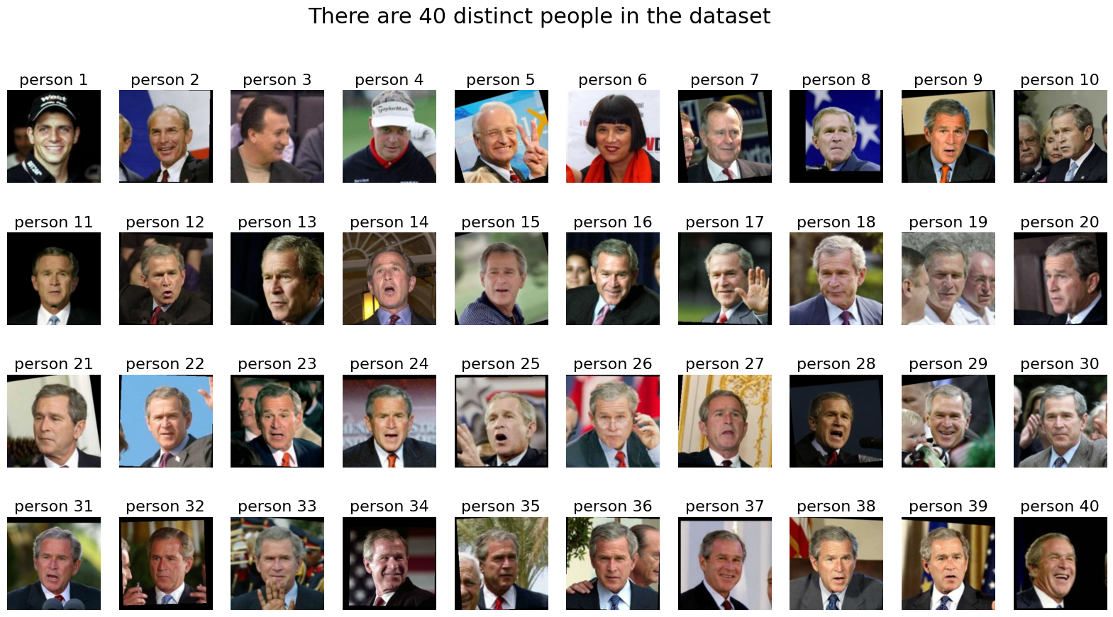

Figure 3.1 Dataset

This study's suggested methodology is broken down into five steps:

**Load Image**

To load a dataset into collab Notebook, use libraries.

**Image Pre-Processing Phase**

To optimize data for machine learning models, there are numerous essential processes in the pre-processing stage when it comes to computer vision or image recognition. To begin with, scaling photographs is necessary to guarantee consistency and model architectural compliance, which speeds up recognition. Normalization, which involves scaling pixel values to a predetermined range, such as 0 to 1, is another crucial step for effective model training and convergence. To improve model generalization, data augmentation is used to provide new training instances using random alterations. Other pre-processing methods include color space conversion, addressing missing data, noise reduction, adjusting contrast and brightness, cropping, and label encoding. By addressing particular data elements, each stage seeks to improve the model's performance and make sure the data is ready for efficient learning and decision-making.

**Data Augmentation:**

It is critical to apply strategies that enhance a machine learning model's overall performance during the training phase. Using methods like flipping, rotating, and zooming to alter the training images is one important strategy. Rotation is the process of turning the images at different angles to make the model invariant under varied orientations. Flipping entails mirroring the photos either vertically or horizontally to expose the model to a variety of viewpoints. By adjusting the image scale by zooming, the model can identify patterns or objects at different magnifications.

**Model Training with Processed Image:**

Once undergoing pre-processing, the image is sent to the first layer of the model. The picture then passes through several convolutional and pooling layers until decision-making is handled by the model's last layer.

**Model Utilization:**

Convolutional neural networks (CNNs) are frequently used in machine learning models, especially when training models for tasks involving images. Because these networks are specifically made to recognize hierarchical features and capture complex patterns within images, they are well suited for image processing.

**Transfer Learning with MobileNetV2**

Apply leveraging as a feature extractor for a pre-trained model (MobileNetV2). This enables you to take advantage of the pre-trained model's knowledge on a sizable dataset. The model is then adjusted for your particular task by adding your own layers on top of it. The pre-trained MobileNetV2 model's layers are frozen, which means that training won't update them. The only layers that will be updated are the ones that you have added and are in training. Preserving the knowledge already present in the pre-trained model is a common practice in transfer learning. You use the Adam optimizer and sparse categorical cross entropy as the loss function when you construct your models. After that, you use the test data to validate your models, train them on the training data, and track their performance over epochs.

**Extraction of Features**

Identifying features is made easier by applying a pre-trained deep learning model. The Keras libraries provide extensive tools to build a neural network customized to our system requirements.

**Hyperparameter Optimizing:**

Optimizing hyperparameters, such as learning rate, batch size, and optimizer settings, is necessary to improve model performance. Methods such as random and grid search are utilized to investigate different combinations of hyperparameter values.

**Decision-Making Algorithm:**

A fully connected layer within the model is in charge of overseeing the decision-making process at the lowest level. This layer evaluates the image by comparing its data with that of the layer above. Convolutional neural network models are used in the training of machine learning models. The phone remains proportionate in both dimensions and weight, which is appropriate given its low-end specs.

**Decision-making of Models:**

A lot machine learning methods, including Support Vector Machines (SVM), K-nearest neighbor (KNN), Random Forests, and Multi-layer perceptron’s (MLP), are assessed during the model selection process. By contrasting each model's accuracy levels and other pertinent metrics, the advantages and disadvantages of each are evaluated.

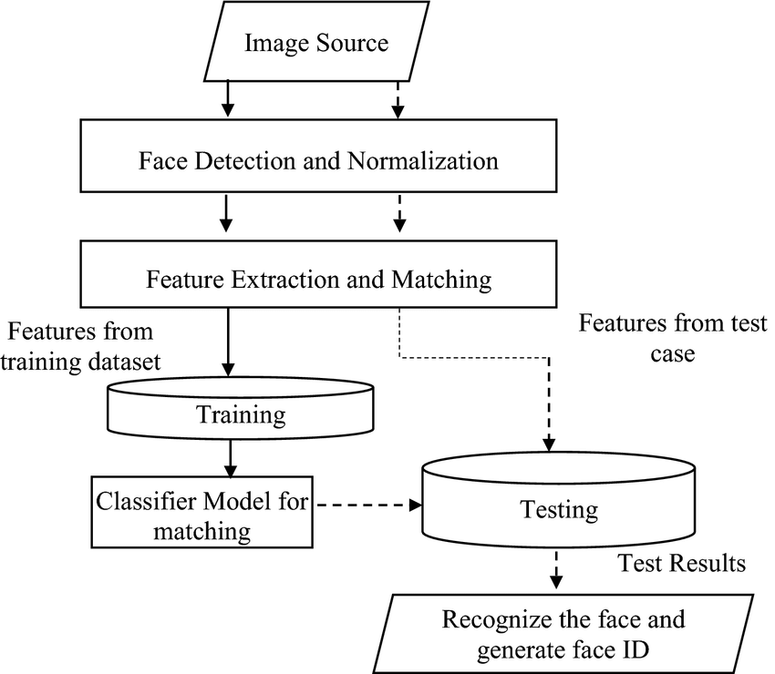

Figure 3. 2 Methodology

## **3.2 System Implementation**

## **3.2.1 System Design Representation**

The system design representation for this project is shown in the diagram below:

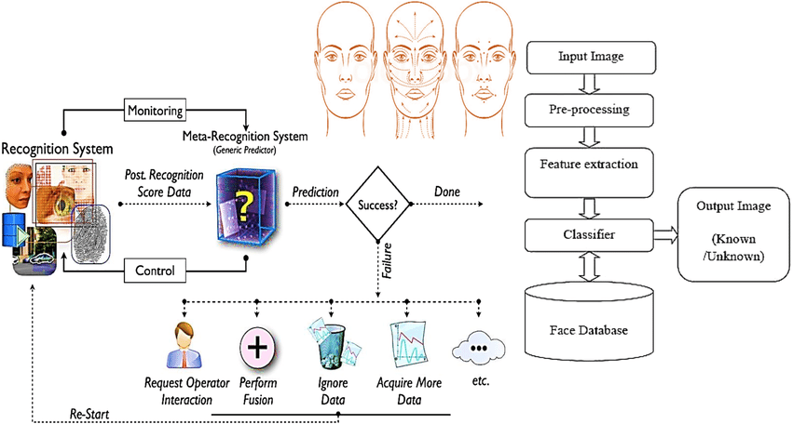

Figure 3.3 System Design

The main components used in this project are shown in the provided diagram, along with their intricate relationships. The six unique modules that make up the system are as follows:

* Image capturing
* Diving into frame
* Feature extraction
* Facial recognition
* Feature extraction via deep Learning
* **Image capturing:**

Our face recognition system starts with image acquisition, which is the process of taking real-time video feeds of people's faces. We turn our attention from tracking moving cars to obtaining facial images. Our approach makes use of smartphone cameras to effectively take the pictures needed for the next steps. This method highlights the usefulness of using widely accessible and portable devices for real-time face data acquisition, like smartphones. Our goal with using smartphone cameras is to make sure that facial data is collected efficiently and dynamically, which will be an important foundation for the subsequent stages of face recognition processing and analysis in the larger context of our system.

* **Face Analysis and Processing:**

The system moves into the face analysis and processing phases after acquiring images. To extract important features and patterns, the gathered facial data is thoroughly examined. The system's embedded facial recognition algorithms use a database and these features to identify and validate people. A crucial component that enables prompt and precise recognition is real-time data processing. This approach is in line with the objectives of the larger investigation and improves face recognition performance. Our face recognition system ensures a smooth and effective method of identifying and verifying individuals using widely available smartphone technology by modifying the image acquisition process and incorporating facial analysis and processing.

* **Dividing into Frames:**

In this particular phase of the procedure, the device performs the vital task of breaking up the supplied housing photos into a series of single images or frames. This segmentation is a tactical method that makes handling smaller, easier-to-manage datasets easier. The gadget efficiently arranges the data by dividing the input images into frames, enabling a more in-depth and precise examination. This is a particularly important step because it simplifies the evaluation process and improves the effectiveness of the processing that comes after. This segmentation produces smaller datasets, which facilitate more focused and resource-efficient calculations, enhancing the device's overall analytical performance. In-depth processing is made possible by this careful partitioning of statistics into frames, which opens the door to more precise and perceptive evaluations in the operation's later phases.

* **Feature extraction:**

At the Feature Extraction stage, the system's ruleset goes beyond the unprocessed image data to isolate and extract meaningful features for each individual in the dataset from each created image. In this context, "features" refers to the discernible qualities that are present in an image and are essential to determining its content. These could be distinguishing shapes, patterns, or other visual components that add to the individuality of every picture. The system efficiently reduces the amount of data and expedites the evaluation process by focusing on these particular features and extracting the crucial information required for identification. This extraction process is essential because it removes unnecessary information and focuses on the unique characteristics that increase the evaluation's accuracy. As such, the process of feature extraction functions as a crucial link between unprocessed image data and distinguishable, meaningful attributes, thereby improving the overall accuracy of the system's evaluation. This particular step is especially important because it simplifies the evaluation process and improves the effectiveness of subsequent processing. The device's analytical capabilities are more effective overall because the smaller datasets that come from this segmentation allow for more focused and resource-efficient computations. This painstaking partitioning of data into frames provides the foundation for comprehensive processing, which in turn enables more precise and perceptive evaluations in the later phases of the process.

* **Facial recognition:**

The face recognition system uses the device's built-in capabilities to recognize and evaluate the Region of Interest (ROI) unique to human faces. This inbuilt mechanism recognizes and focuses on facial features within the captured image, functioning as the system's eyes. In face recognition, precise identification and comprehension of the facial region are essential for accurate recognition and further analysis, much like in the diagnosis of a disease through leaf identification. The apparatus utilizes sophisticated algorithms and image processing techniques to guarantee accurate identification of facial features, providing the groundwork for comprehensive and detailed evaluations in the later phases of facial recognition procedures. This first stage is crucial to the face recognition mechanism as a whole because it sets the parameters for the device's capacity to recognize and understand human faces in the surrounding context.

**Feature extraction via deep Learning:**

This first phase is crucial to the device's overall face recognition process because it establishes the parameters for its capacity to identify and comprehend human faces in the provided environment. The system uses advanced deep learning models, which are basically multi-layered neural networks, for feature extraction during the deep learning stage. These models have already undergone pre-training on large datasets in order to efficiently understand common visual patterns. The extraction of useful capabilities from the images is a critical step in this process. The system is able to identify and comprehend complex features that might be indicative of diseases thanks to the deep learning models' analysis of minute details and subtle patterns in the input images. The device is able to identify subtle visual cues linked to diseases and extract meaningful information by utilizing the pre-trained knowledge of neural networks. By applying the learned representations from the deep learning models to identify complex features within the images, this feature extraction step significantly improves the system's accuracy and dependability in identifying diseases, leading to more efficient disease detection and analysis.

**3.2.2** **Implementation Tools and Frameworks**

This project can be implemented using a variety of tools and frameworks, providing a wide range of possible mechanisms and architectures. The following elements are used in the project

**Jupiter Notebook:** An adaptable environment for programming.

**Libraries:** For improved functionality, make use of libraries like Kera and CV2.

**CV2:** Press the button to start using a webcam to record facial data with CV2.

**Matplotlib and Seaborn:** Use these programmers to create graphs.

**Convolutional Neural Network (CNN):** Use a Deep Learning model based on CNN to extract features.

Additional Machine Learning Architectures: Examine a variety of models for machine learning, such as Random Forest, MLP, SVM, and KNN. The project code is divided into discrete sections, each devoted to a particular model that was used in the process of implementation.

# **3.2.3 Research Plan and Task Lists**

The dependability and quality of the input data are crucial to any model's effectiveness in the fields of machine learning and computer vision. Important phases like feature engineering, transformation, and data purification are included in this framework's definition of the data preparation process. Together, these crucial stages guarantee that the data are prepared for in-depth analysis, which permits the production of precise forecasts and perceptive conclusions. We examine these basic mechanisms within the framework of image analysis in this session, using a variety of instruments and techniques to achieve a thorough comprehension.

**Data Cleaning Process:**

It is essential to make sure that the supplied images are clean and devoid of anomalies before starting any analysis. The OpenCV library, a well-known computer vision tool, is used to accomplish this. The first steps involve loading and preparing the images. After that, they are saved as an array, loaded into the RGB format, and resized to the necessary dimensions, creating a tidy and controllable dataset. It is essential to take into account any possible risks related to the dataset during this process. While the exacts of pre-loading record cleaning are not described, it is possible that steps like addressing missing labels, getting rid of bad images, and getting rid of duplicates were taken. These steps improve the dataset's overall reliability by providing a solid basis for further research.

**Data Transformation and Wrangling:**

One of the key components of data science is the process of transforming unprocessed data into an understandable format. Within the field of image analysis, data wrangling refers to the process of reorganizing, reformatting, and modifying data in order to guarantee its maximum usefulness. In order to correctly record data in the codebase and present it in a way that supports the goals of any adjustments made to the image data for modelling or analysis, pre-processing is necessary. Prior to analysis, the data is loaded, scaled, and normalized using OpenCV and TensorFlow's ImageDataGenerator. When it comes to managing image data, normalization is especially important because it makes meaningful and consistent comparisons of pixel values between various images possible.

**Feature** **Enhancement:**

Feature engineering is the art of transforming the wealth of information contained in raw pictures into usable and instructional attributes. These qualities serve as the building blocks for machine learning models, enhancing their ability to spot patterns and make accurate predictions. Convolutional Neural Networks (CNNs) are used as the major tool in feature engineering in the context of the code to extract relevant features from the images. The convolutional layers of a CNN are very good at extracting small information from images, such as edges, textures, and patterns. These flattened features are used in further machine learning models. Feature engineering improves performance by correctly storing visual cues that enable the model to generalize from the training data to fresh, undiscovered images.

* **Image Convolutional Models:**

Convolutional Neural Networks (CNNs) are a subset of deep learning networks that are specifically designed for use in computer vision, image recognition, and pixel-level input analysis. With the capacity to recognize hierarchical patterns and features in images, CNNs have become an extremely powerful tool for processing complex visual data. Their ability to identify complex elements like edges, textures, shapes, and object components is especially demonstrated in image identification tasks. As a result, CNNs perform admirably on tasks such as object detection, facial recognition, and scene classification.

* **Mobile _NetV2 transfer learning:**

For transfer learning, a pre-trained MobileNetV2 model is used, specifically for a custom classification task. As a feature extractor, the foundational MobileNetV2 model is loaded with weights that have been previously trained on ImageNet. Later, the model is extended with more layers: a dense layer with 128 units and ReLU activation, a global average pooling layer, and a final dense layer with SoftMax activation corresponding to the target number of classes (num_classes). Notably, only the recently added layers are trainable, and the base model's layers are frozen to maintain the previously learned information during training, reducing the chance of overfitting.

**• Identification of Features and Hierarchical Data Analysis:**

The ability of CNNs to extract hierarchical features from data is a crucial capability. Convolutional, pooling, and other layers are included in the architecture. The network can understand intricate visual patterns by identifying increasingly abstract features at each layer.

* **Convolutional Layers**: Convolutional layers are the building blocks of CNNs and are essential to their operation. These layers use convolutional methods, which analyses input images by applying tiny filters called kernels. These filters work methodically to identify particular elements in the image, like textures or edges. The network achieves translational invariance by using convolutional layers with shared weights, which enables it to identify features regardless of where they are located in the image.
* **Pooling layers are inserted between convolutional layers.** CNNs are built around convolutional layers, with pooling layers inserted in between. These layers lessen the spatial dimensionality of feature maps while preserving important information. Pooling layers, which frequently use methods like max and common pooling, are intended to reduce computation costs and improve the network's resilience to perturbations.
* **Convolutional layers:** provide the structural basis of CNNs. These layers use convolutional algorithms to apply multiple discrete filters, also called kernels, throughout an input image. These filters draw attention to particular textures or edges in the picture. Translational invariance is a feature of convolutional layers that allows them to interpret features independent of their location in an image. This is accomplished by allocating shared weights to the layers.
* **Pooling Layers:** Distributed pooling layers are positioned strategically within convolutional layers. These layers reduce the spatial extent of feature maps while preserving important information. Well-known pooling strategies, like average and max pooling, are used to maximize computational effectiveness and strengthen the network's resistance to input fluctuations.
* **Fully Connected Layer:** Additionally referred to as the Dense Layer, this part of neural networks is essential because it makes it easier to identify complex correlations in data.
* **Utilizing Random Forest Model:**

One popular supervised machine learning technique for solving problems with regression and classification is Random Forest. Using the majority vote for regression and the average of samples for classification, this method builds decision trees. Most notably, for classification purposes, the Random Forest Algorithm performs exceptionally well with datasets that combine continuous variables for regression and categorical variables for classification. Its ability to produce better results is especially noticeable in classification problems.

* **Utilizing Support Vector Machines (SVMs) Model:**

Supervised machine learning techniques such as Support Vector Machines (SVMs) are useful for tasks involving regression and classification. SVMs are applied to image classification in this work. A digital photo is transformed into a two-dimensional grid of pixels when it shows up on a computer screen. For example, the array will be structured as 200 pixels wide by 200 pixels high by 3 elements deep if the image has a resolution of 200 pixels in width and 200 pixels in height. The width and height of the image are indicated by the first two dimensions, and the RGB color channels are indicated by the third dimension. A brightness value, denoted by a number between 0 and 255, is assigned to each pixel.

* **Neighborhood-Based Learning with K-Nearest Neighbors (k-NN):**

K-Nearest Neighbors (k-NN) is a supervised learning method that takes a labelled training set (X) and its associated labels (Y) to create a set of rules. Mapping input data (X) to corresponding expected output (Y) is its main function. One particularly important tool in this learning process is the k-NN approach. To put it simply, it means taking in all of the training data and creating a cluster that is mainly made up of the 'k' nearest neighbors, ascertained using a given distance measure. In order to clarify the operational process, the model is given a test snapshot after saving the training data for prediction. Then, by measuring the distance between each training image and the test image, the model determines which of the 'k' training images most closely resembles the test image. The final prediction is then determined by a voting procedure that uses the labels of these "k" neighbors, usually a majority vote.

* **Multi-Layer Perceptron (MLP):**

A popular artificial neural network architecture for supervised learning tasks is the Multi-Layer Perceptron (MLP). Because of the non-linear activation functions in the hidden layers, multilayer projections (MLPs), which consist of an input layer, one or more hidden layers, and an output layer, are effective at modelling complex relationships within data. Backpropagation is a technique used by the network to fine-tune its weights during training, changing parameters to reduce the difference between expected and actual values. MLPs are useful in many different fields, such as financial forecasting and image and speech recognition, because of their versatility and ability to perform a range of tasks, such as regression and classification. Nonetheless, difficulties like overfitting, high computational demands, and the requirement for rigorous data preprocessing highlight how crucial careful architecture design and hyperparameter tuning are. In spite of these factors, MLPs continue to be essential in the field of artificial neural networks and have a major impact on the development of machine learning applications.

**Algorithm Purpose:**

* All of the images go through preprocessing and alternate resizing procedures with specific code.
* To improve the dataset's robustness, rotation is applied during image ingestion to account for variations in facial orientations.
* In order to ensure that the dataset highlights facial features, the algorithm specifically takes focused pictures of faces.
* Convolutional Neural Network (CNN) training requires the necessary preprocessing of images.
* To ensure compatibility with the CNN model that follows, a dedicated script is used to convert all images into NumPy Arrays.
* The basis for model training is formed by the generation of distinct education sequences that are categorized based on tagged and parsed images.
* Grayscale image reduction is a further processing step that optimizes the images for the ensuing training steps.
* Convolutional neural networks (CNNs) are used in the algorithm to extract features and learn from the preprocessed images.
* The final model is saved after training, and its effectiveness is evaluated by displaying its predictions on test images. The evaluation of the assessment aids in determining how well the model recognizes facial features.

# **Chapter 4**

## **EVALUATIONS**

## **Code:**

This section provides a thorough explanation of the experiment, going into great detail about every tactic, technique, and instrument used. The objective is to provide a comprehensive understanding of the instruments employed and the procedural actions conducted during the experiment.

## **Code Setup:**

In this section, the methods used to recognize the face. Models are trained using a Jupiter notebook (likely a Jupiter Notebook) using a facial recognition dataset. The apparatus, platforms, and data sources that will be used throughout the experiment are listed in more detail in the experimental setup.

## **Code Design/Details:**

This section will examine the code design and implementation, with a particular emphasis on facial recognition technology. The experiment's goal is to develop a facial recognition technique. Importing pertinent libraries, training models, running tests, and producing predictions are some of the tasks involved in the process. This section functions as a description of how the experiment was carried out as well as a guide for duplicating the outcomes.

**Loading in the required libraries:**

An important first step in the experimentation process is to include the necessary libraries. The importance of making sure your code includes all necessary libraries and dependencies cannot be overstated. These libraries usually provide the tools required for a variety of tasks, including handling data, processing files, optimizing models, visualizing data, and more. After these libraries are successfully imported, you can move on to the next stages of the experiment.

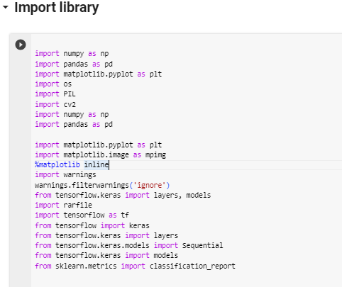

Figure 3.4 Import Libraries

## **Load Dataset:**

The installation of necessary libraries, such as rarfi­­­le, OpenCV-python, and TensorFlow, precedes the dataset loading procedure in the code that is provided. Then, the dataset source is set to the lfw_funneled.rar file, and the rarfile library is used to work with the compressed file. The RAR file's contents are listed, displaying information about the files, sizes, and compression ratios. After that, the files are extracted to a special directory called "face Dataset." The 'Labelled Faces in the Wild' (LFW) dataset is the source of this dataset, which consists of face photos. For the preprocessing and analysis that follow, the extraction procedure is essential. The code offers a methodical method for loading datasets, guaranteeing that the required face images are available for additional processing and machine learning model training.

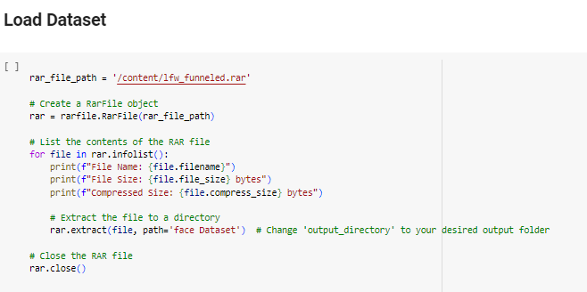

Figure 3 5 Load Dataset

## **Augmenting Data and Preprocessing**

The preprocessing and augmentation stages of the data are essential parts of the algorithm. To improve their suitability for training machine learning models, the images go through a number of preprocessing steps after the dataset is loaded. Establishing the data directory and the target image size is the first step in the preprocessing process. The next step involves the introduction of a function called **load_and_preprocess_images,** which processes each image in the dataset iteratively. OpenCV is used to load the images, convert them to the RGB colour space, and then resize them to the desired sizes. This guarantees the dataset's consistency and uniformity. Image augmentation is applied to further improve the robustness of the model and the variability of the dataset. The purpose of the augment image function is to use OpenCV to apply desired augmentation techniques, like rotation and flipping. The effectiveness of the augmentation process in adding diversity to the dataset is then demonstrated by visualizing the augmented images for a selection of random classes. All things considered, the phases of data augmentation and preprocessing are crucial in getting the dataset ready for training. The technique attempts to enhance the model's performance on a variety of facial features and generalization abilities by standardizing the images and adding variances via augmentation. These preprocessing methods help to produce a representative and well-structured dataset, which lays the groundwork for efficient machine learning model training.

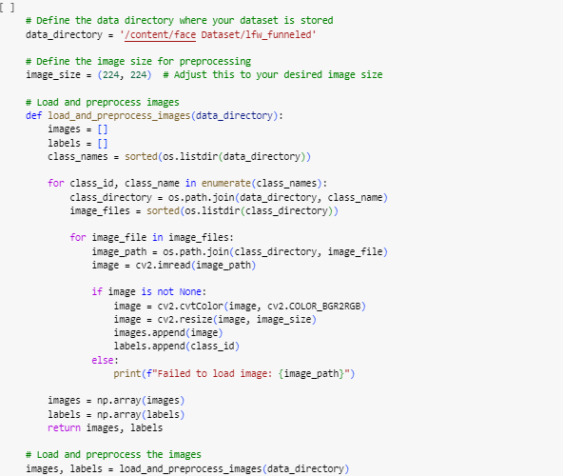

Figure 3.6 Preprocessing

## 

Figure 3. 7 Image Augmentation

## **Feature Extraction:**

In machine learning, feature extraction is an essential step, especially when dealing with image recognition and classification applications. It entails converting unprocessed input data—like pictures—into a more controllable and representative collection of features. The provided code performs feature extraction implicitly during the training and assessment of a number of models, including MobileNetV2 transfer learning and Convolutional Neural Networks (CNNs).

## **Convolutional Neural Networks (CNNs):**

The convolutional and pooling layers of the CNN architecture are fundamentally based on feature extraction. These layers capture hierarchical features like edges, textures, and shapes by methodically analyzing local patterns in the input images. The network gains the ability to extract ever-more-abstract and complex features as it moves through the layers, enabling it to discern minute patterns in the dataset.

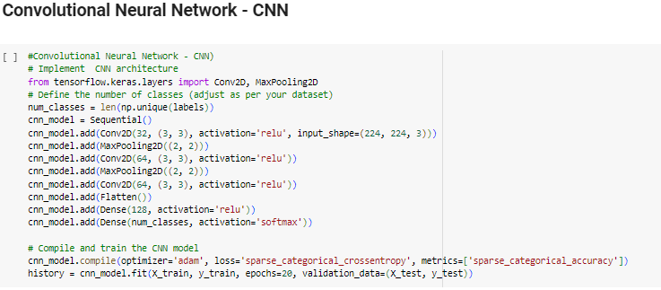

Figure 3. 8 CNN Model

## **CNN Model Learning Curve:**

The Convolutional Neural Network (CNN) model's learning curve graph in the code shows interesting patterns over the course of the training epochs. The plot provides a dynamic viewpoint on the model's capacity to learn from the dataset by showing the evolution of both the training and validation losses. While tracking validation loss aids in identifying possible overfitting or generalization problems, a declining training loss signifies successful adaptation to the training set. The graph presents the training accuracy and validation accuracy trends simultaneously, giving users a thorough understanding of the model's ability to classify both seen and unseen data with accuracy. The learning curve helps determine the ideal point for model training by monitoring the convergence and possible divergence of these metrics, striking a balance between efficient learning and avoiding overfitting.

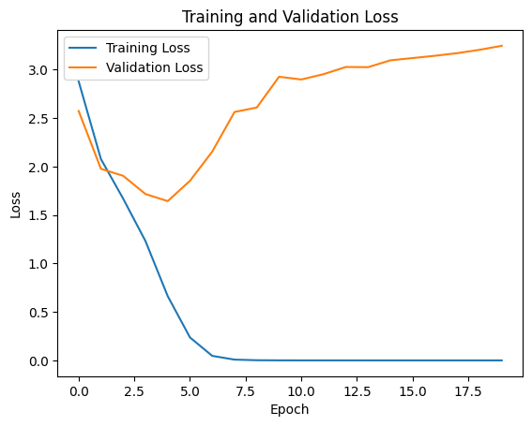

Figure 3.9 CNN Model Learning Curve:

## **Mobile – Net Transfer Learning**

A pre-trained model on a sizable dataset is utilized for transfer learning with MobileNetV2. As a feature extractor, the pre-trained model retains information gleaned from a variety of images. The model is adjusted on the particular face dataset by adding more layers to the pre-trained base, which allows it to modify its learnt features for face recognition. In order for a face recognition model to recognize distinguishable facial features, independent of changes in posture, illumination, or expression, feature extraction is crucial. The derived characteristics form the basis for efficient pattern identification and categorization, which enhances the model's capability to precisely differentiate between various people. In conclusion, the provided code leverages feature extraction, which is implicit in the CNN architecture, through transfer learning using MobileNetV2. Robust face recognition capabilities are made possible by these techniques, which allow the models to automatically learn and extract relevant features from facial images.

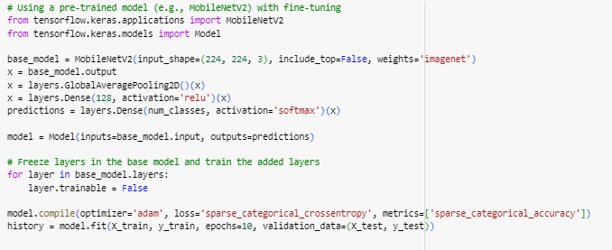

Figure 3.10 Mobile - NET

## **Mobile – Net Learning Curve:**

The MobileNetV2 model's learning curve graph illustrates important aspects of training dynamics. A key indicator of the model's learning effectiveness, the plot shows the trajectory of training and validation loss. Robust learning and adaptation to the dataset is indicated by a steady decline in both training and validation loss. The training accuracy and validation accuracy graphs that go with the model provide insight into how well the model generalizes to fresh, untested data. Analyzing the curves closely provides important insights into the model's generalization abilities by determining the degree of convergence between training and validation metrics. In order to optimize the MobileNetV2 model and guarantee the best possible performance and accuracy in face recognition tasks, these learning curves are crucial tools.

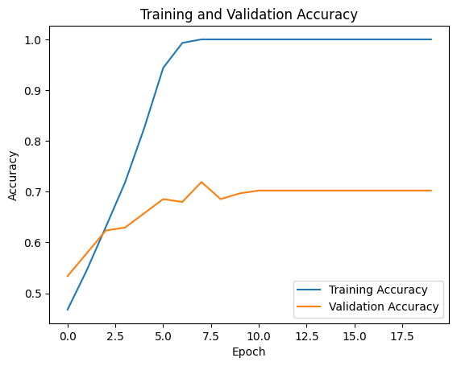

Figure 3. 11 Mobile – Net Learning Curve

## **Data Splitting:**

The Sklearn. model selection module's train_test_split function divides the dataset suitably into training and testing sets. This step is essential for determining how well the model performs on data that it hasn't seen during training, which aids in determining how well it can generalize. Splitting takes place prior to model training and following the data preprocessing stages. The preprocessed images (X) and the labels that correspond to them (y) are fed into the train_test_split function. The dataset is divided into two subsets, one for training and the other for testing, and is then randomly shuffled. As indicated by the Test_size parameter, the standard practice is to assign a specific percentage of the data—in this case, 20%—to the testing set.

Furthermore, 'uint8' for the image data types and 'int' for the label data types are explicitly set for the training and testing sets. Consistency in data representation is ensured by this standardization. In addition, the images' pixel values are normalized to the interval [0, 1], a standard procedure in image processing that helps to stabilize the training process. The code creates a distinct boundary between the dataset used to train the model and the dataset set aside for assessing its performance by dividing the data in this way. This separation gives a reliable measure of the model's performance in face recognition tasks and permits a robust evaluation of the model's capacity to generalize to new, unseen data.

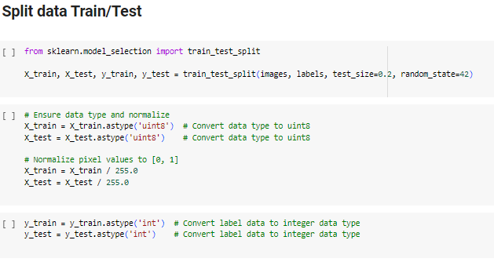

Figure 3. 12 Split Data

**Assessment of Model**

Machine learning algorithms are evaluated based on a number of metrics. The dynamic interaction between true positives (TP), false positives (FP), false negatives (FN), and true negatives (TN) is examined in order to obtain information. A matrix table is frequently used to evaluate a classifier's performance. Five metrics—classification accuracy, sensitivity, specificity, F1-score, support, and area under the receiver operating characteristic (ROC) curve—are frequently used to assess classifiers. Based on the parameters TN, FP, TP, and FN, classification accuracy—which is the percentage of correctly classified instances—is calculated. Conversely, sensitivity measures how accurately a patient diagnosis is made.

**Accuracy:**

Specificity, also known as the true negative rate, quantifies the capacity of a classifier to identify and omit non-positive examples. When datasets are imbalanced—that is, when one class greatly outnumbers the other—this metric becomes even more important. Evaluating a model's specificity yields information about how well it can detect and rule out false events, enabling necessary adjustments.

--------------------------------- (1)

**Precision:**

Accuracy assessment of a classification model heavily depends on precision, especially when false positives are an issue. It provides information about how consistently the model produces accurate predictions. ------------------------- (2)

Let's dissect the elements of this equation:

**True Positives (TP):** True Positives (TP) are examples of situations in which the predictions come true because the right people or cases have been identified. For instance, the system unlocks the entrance door to allow access if the algorithm is successful in matching the authorized employee's stored data with the captured facial features. A successful face recognition event in this case is referred to as a "True Positive," since the employee was successfully identified and authenticated by the system, granting them entry to the building.

**False Positives (FP)** When something is mistakenly assigned to a category it does not belong in, it can lead to False Positives (FP). This can happen in the medical field, for example, if the model incorrectly diagnoses a patient who is healthy. In this context, accuracy refers to the frequency with which the model accurately forecasts a particular outcome, like recovering from a particular illness. It measures how frequently these forecasts agree with accepted standards. Stated differently, the rate at which accurate predictions are produced is reflected in the accuracy of the model. High precision methods show that the model can predict a positive outcome with a reasonable degree of accuracy. However, low accuracy indicates that the model is predicting many positive outcomes incorrectly. Accuracy is essential because false positives can have unfavorable effects. For instance, in a medical setting, incorrectly diagnosing a healthy person as having a contamination may result in needless treatments and increased patient stress. In these situations, a more accurate model is required.

It's crucial to remember that sensitivity and accuracy are frequently at odds with one another; sensitivity tends to rise when accuracy declines and vice versa. By taking into account both kinds of accuracy, the F1-score manages this trade-off and offers a fair assessment of a classifier's performance.

**Recall:**

Even in the face of possible errors, it is crucial to keep a careful record of every positive instance when performing classification tasks. In these kinds of situations, recall—also known as sensitivity or the true positive rate—is an essential performance indicator.

------------------------------ (3)

Dissecting the elements of this formula:

**True Positives (TP):** It is reasonable to conclude that the appropriate class should be associated with that context, given that it has been accurately forecasted under these circumstances.

**False Negatives (FN)** These events, which fall into a particular category, are erroneously expected to have left that category. Recall measures the proportion of examples in a class (people with a specific disease, for example) that the model correctly predicted. Recall, to put it simply, evaluates how well the model recalled genuinely noteworthy events. When it correctly identifies most of the positive examples in the dataset, the model demonstrates extreme forgetfulness. But this increased forgetfulness also contributes to an increase in false positives, or cases that are mistakenly labelled as positive. This demonstrates the trade-off between accuracy and remembering things. Prioritizing recall becomes important when there are substantial consequences for forgetting noteworthy events.

**F1- Score:**

A statistical metric called the F1-score combines recall (sensitivity) and precision into a single number. Recall measures the ratio of correctly predicted positive events to all positive instances, whereas precision represents the ratio of accurately predicted positive cases to all expected positive cases. With the ability to account for both false positives and false negatives, the F1 score provides a thorough assessment of a classifier's performance. It is especially helpful when trying to strike a balance between recall and precision. A high F1 score is the ideal metric if you want to attain high precision and significant recall.

-----------------------------------------------------(4)

**Comparing Classifiers:** A thorough understanding of the performance of two distinct classifiers can be obtained by taking accuracy, specificity, and the F1-score into account. Because accuracy takes a broad view, it may not provide a thorough evaluation of correctness in situations where datasets are unbalanced. Specificity is useful in detecting unwanted examples, and the F1 score is a good compromise between recall and precision. It's critical to understand that no single statistic can be used in all situations, as the selection of a metric is contingent upon the particular goals of your application.

## **Random Forest:**

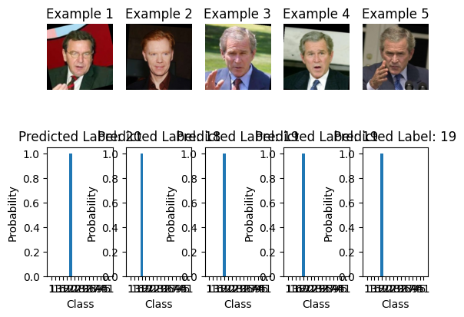The procedure of building a Random Forest classifier and assessing its performance using the attributes of a pre-trained deep learning model. A deep learning model is first loaded, and its pre-trained layers are used to extract features from the training and test datasets. The retrieved characteristics from the training set are then used to train a Random Forest classifier. Next, labels for the test set are predicted using the trained model. The `accuracy_score` function is used to assess the Random Forest model's accuracy, and the `classification report` function is used to produce a thorough classification report. Lastly, a graphic depiction of a few selected instances from the test set is shown, presenting the input pictures with the probability distribution of the predicted labels. This thorough method shows how to combine conventional machine learning methods with deep learning to provide a reliable and understandable classification result.

Figure 3. 13 Random Forest

## **Support Vector Machine:**

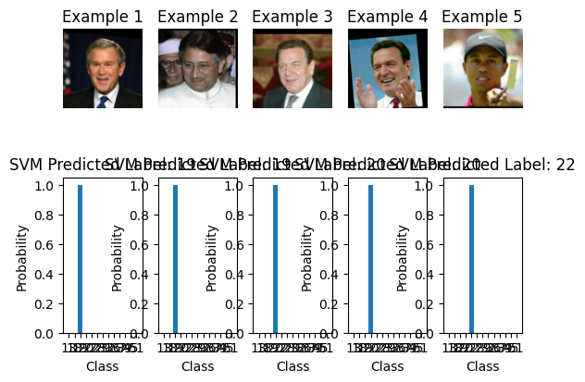The pre-trained deep learning model's features are taken out and used to classify data using a Support Vector Machine (SVM). To predict labels for the test set ({X_test_features}), the SVM model is built up with a linear kernel, trained on the training features ({X_train_features}). The `accuracy_score` function is then used to determine the SVM model's accuracy, and the `classification report` function is used to create a thorough classification report. A few randomly selected samples from the test set are also shown, together with the predicted labels and the associated probability distribution for the SVM model, to further visually represent the results. With this, Support Vector Machines are fully integrated into the current process, enabling a performance comparison between the Random Forest classifier and the SVM model.

Figure 3.14 SVM

## **K Nearest Neighbor:**

The pre-trained deep learning model's features are taken out and used to implement the K-Nearest Neighbors (KNN) algorithm for classification. After being trained on the training features ({X_train_features}), the KNN model is set up with five neighbors and used to predict labels for the test set ({X_test_features}). The `accuracy_score` function is then used to determine the KNN model's accuracy, and the `classification report` function is used to print a thorough classification report. Like the earlier examples, a few randomly selected examples from the test set are shown together with the predicted labels and the associated probability distribution for the KNN model to visually represent the results. With this, K-Nearest neighbors is fully integrated into the current workflow, allowing for a thorough analysis and 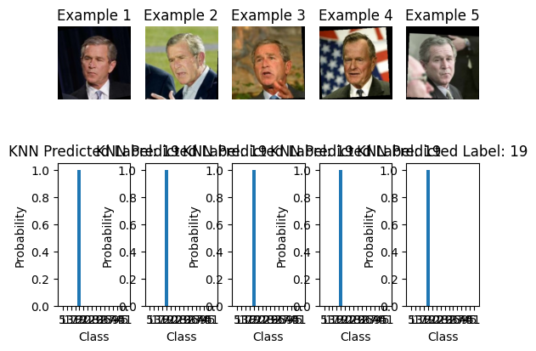comparison of various machine learning algorithms.

Figure 3.15 KNN

**Multilayer Perceptron-MLP Classifier:**

The features taken out of the pre-trained deep learning model are used to implement a Neural Network (NN) classifier. The neural network model has two hidden layers with 100 and 50 neurons each, and it can be trained for up to 1000 iterations. After being trained on the training features ({X_train_features}), the model is applied to the test set ({X_test_features}) to predict labels. The `accuracy_score` function is used to determine the accuracy of the Neural Network model, and the `classification report` function is used to print a thorough classification report. Furthermore, just like in the earlier instances, the outcomes are shown graphically by showing a few chosen instances from the test set together with the Neural Network model's predicted labels and associated probability distribution. A comprehensive comparison of the effectiveness of various machine learning algorithms within the specified workflow is made possible by this inclusion.

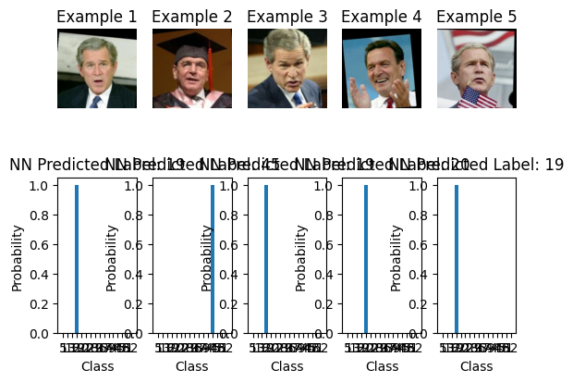

Figure 3.16 MLP

### **Results and Findings:**

The results when three different models are applied are displayed in Table 3.1. Every model offers the highest level of precision. The best testing and learning strategy are Random Forest.

Table 4.1 Results of Model

|  |  |
| --- | --- |
| **Model** | **Accuracy%** |
| **Random Forest** | **74%** |
| **Support Vector Machine** | **72%** |
| **Multiple Layer Perceptron** | **73%** |
| **K- Nearest Neighbor** | **71%** |

## **Performance Validation:**

The thorough performance assessments of the models demonstrate the potency and efficacy of our approach. The Support Vector Machine (SVM) technique demonstrated an improved accuracy of roughly 72%, highlighting its ability to identify patterns in the dataset. In the meantime, the K-Nearest Neighbors Classifier (KNN) showed that it could distinguish minute variations and similarities in the function space, improving accuracy to about 71%. The Random Forest ruleset outperformed all other options with an astounding 74% accuracy rate, demonstrating its skill at identifying subtle relationships in the dataset. Through comparing the results of various precision evaluations, we are able to determine which rule sets are more advantageous. It is obvious that choosing the right set of regulations is crucial. The Random Forest rule set's ensemble-based design makes it a better tool for capturing complex relationships than the SVM and KNN algorithms, which are primarily focused on pattern recognition.

## **Risk Assessment and Management**

A number of obstacles could appear during the study process and have an impact on the project's conclusion. These difficulties include possible confidentiality violations, technical difficulties, moral dilemmas, and legal compliance. Several actions will be taken in a proactive manner to solve these issues:

1. Potential privacy breaches,
2. Technical challenges,
3. Ethical concerns,
4. Legal regulations.

**Privacy Protection:** By obtaining informed consent and guaranteeing the confidentiality of the participants' data, the researchers will place a high priority on protecting the participants' privacy. Furthermore, meticulous testing and design will be used to strong machine learning models in order to reduce technical risks like bias and data processing problems.

**Ethical Concern:** The researchers will respect ethical norms and give participant privacy top priority in light of the moral ramifications of facial recognition technology. Throughout the research, morality and data security will play a major role in the decision-making process.

**Legal regulations:** The research will strictly abide by all applicable rules and regulations, acknowledging that the gathering of personal data for facial recognition technology is subject to regulatory limits. Adherence to legal frameworks will be a vital facet of the study methodology.

**Technical Challenges:**  The team will concentrate on resolving concerns with model accuracy, potential biases, and other technological complications, acknowledging that there may be technical obstacles in the study process. To meet these obstacles, regular algorithm testing, validation, and continual improvement will be essential strategies.

A comprehensive risk management plan will be created to systematically manage these challenges. This plan will outline strategies for identifying, assessing, and mitigating risks to ensure that the study is conducted safely, ethically, and in accordance with legal standards. By proactively addressing potential technical challenges along with privacy, ethical and legal considerations, the research aims to foster a safe and responsible environment for conducting facial recognition research.

# **Chapter 5**

## **5.1 Conclusion**

In conclusion, this paper provides a comprehensive analysis of a face recognition system designed for online proctoring, based on a global feature extraction method based on Histogram-Oriented Gradient. The methodology highlights real-time face tracking and detection, showing significant relevance in machine interaction systems. The system starts with an accurate in-the-moment learning process that enables the machine to track the right person under a variety of circumstances, including changes in scale, pose, and camera angles. This study's approach to face recognition presents a comprehensive and methodical methodology covering important phases, such as loading the dataset and model evaluation. By carefully adding data augmentation and preprocessing, the procedure makes sure the dataset is ready for later machine learning model training. The representational features of the dataset are improved through feature extraction, which is done both explicitly using MobileNetV2 transfer learning and implicitly using Convolutional Neural Networks (CNNs). The learning curves of the CNN and MobileNetV2 models provide dynamic insights into their training dynamics. The train_test_split function helps to create a distinct division between the training and testing sets through data splitting. Metrics like accuracy and precision are used to evaluate the models, and the Random Forest model is found to be the most successful with an impressive accuracy of 74%. This methodology, which integrates cutting-edge data processing, feature extraction, and model evaluation techniques, offers a solid framework for the creation of precise and dependable face recognition systems.

## **5.2 Ethics, Legal, Social, Security and Professional Consideration**

For this study, demographic information and facial image data are among the private information that will be gathered. To protect participant privacy and data security, ethical principles will take precedence. In accordance with applicable privacy laws and regulations, all participants will give their informed consent, and their data will be anonymized to ensure confidentiality. The study will go into great detail about the societal, legal, and ethical ramifications of federated learning and facial recognition technology. It seeks to investigate how federated learning might allay ethical worries, abide by data privacy regulations, and conform to professional norms for research ethics. Priority will be given to security measures for research infrastructure and participant data. To preserve the openness of the research process, the researcher publishes findings in peer-reviewed journals and at conferences, demonstrating their commitment to accountability, transparency, and replicability.

**Ethical considerations:**

In the realm of facial recognition technology, ethical considerations take center stage, demanding meticulous attention throughout the development and deployment processes. The intricacies of collecting, storing, and processing facial data inherently raise profound issues related to individual privacy, the necessity of consent, and the potential for misuse. To navigate this ethical terrain successfully, researchers and developers must prioritize several key principles. Transparency emerges as a foundational ethical requirement. Developers must be transparent about how facial data is collected, processed, and utilized. This transparency fosters trust and empowers individuals with a clear understanding of how their data is being utilized, promoting accountability within the technological ecosystem. Informed consent stands as a non-negotiable ethical standard. Individuals must be provided with comprehensive information about the purpose and scope of facial data processing, and their explicit consent should be obtained before any data is collected. This ensures that individuals have agency over their personal information, reinforcing the principles of autonomy and respect for individual rights. Mitigating biases is another critical ethical imperative. Developers must actively work to eliminate biases in facial recognition algorithms to prevent the reinforcement of societal prejudices. This involves continuous monitoring, evaluation, and adjustment of algorithms to ensure fairness and avoid discriminatory outcomes. Overall, ethical frameworks should underpin the entire lifecycle of facial recognition technology, guiding its responsible use. This involves not only complying with legal standards but going beyond to prioritize respect for the rights and dignity of individuals. By adhering to these ethical considerations, developers contribute to the creation of a technological landscape that is not only innovative but also respects and preserves the values and rights of individuals within society.

**Legal aspects:**

The deployment of facial recognition technology operates within a complex legal framework that encompasses crucial domains such as data protection, privacy, and surveillance. Navigating this legal landscape is imperative to avoid legal consequences and ensure responsible and ethical use of the technology. Key legal considerations include stringent compliance with data protection laws, securing explicit consent for data processing, and adherence to regulations governing the handling of biometric data. Compliance with data protection laws is paramount, requiring developers to safeguard the privacy and rights of individuals whose data is being processed. This involves adopting robust measures to ensure data security, integrity, and confidentiality. Additionally, obtaining informed consent from individuals for the processing of their facial data is a foundational legal requirement, emphasizing transparency and empowering individuals with control over their personal information. Specific regulations governing biometric data, given its sensitive nature, necessitate meticulous adherence. Developers must understand and comply with these regulations to mitigate the risk of legal complications. Such regulations often mandate strict controls on the collection, storage, and use of biometric data, requiring developers to implement secure and ethical practices. By proactively addressing these legal aspects, developers not only safeguard their projects from potential legal challenges but also contribute to the responsible and lawful integration of facial recognition technology. Adhering to legal requirements ensures that the deployment of facial recognition aligns with societal values, upholds individual rights, and operates within the bounds of legal and ethical norms.

**Social aspects:**

The societal ramifications of facial recognition technology stretch beyond its technical capabilities, delving into critical areas of public trust, discrimination, and social norms. Developers bear the responsibility of understanding the broader impact of their technological innovations on communities and individuals alike. This involves a meticulous examination of the potential implications on public trust, recognizing the concerns surrounding discrimination, and acknowledging the influence on established social norms. A paramount consideration lies in addressing issues related to bias, inclusivity, and the potential for social division. The technology's application should not inadvertently perpetuate or exacerbate societal inequalities. Instead, it should aim for inclusivity, ensuring that its benefits are accessible to diverse demographic groups. Tackling bias in facial recognition algorithms becomes imperative to prevent discriminatory outcomes that might disproportionately affect certain communities. To navigate these intricate social dynamics, developers must actively engage with various stakeholders, particularly those communities directly impacted by the technology. This engagement facilitates the incorporation of a broader spectrum of perspectives, fostering a collaborative approach to technology development. By doing so, developers contribute to the promotion of socially responsible practices, aligning technological advancements with societal values and ethical considerations

**Professional Considerations:**

The development and deployment of facial recognition technology requires adherence to professional standards and guidelines. Professional considerations include the responsible conduct of research, transparent communication with stakeholders, and a commitment to continuous learning and improvement. Cooperation with professional organizations and adherence to industry best practices contributes to the credibility and ethical standing of those involved in the development and application of facial recognition technology.

# References

Artiges, C. E. (2017). “Strengths and Weaknesses of Deep Learning Models for Face Recognition Against Image Degradations.

E. García Amaro, M. A.-M. (2019). Evaluation of machine learning techniques for face detection and recognition,. *CONIELECOMP 22nd International Conference on Electrical Communications and Computers*.

Farhad Navabifar, M. E. (n.d.). A short review paper on Face detection. *2011*.

J. C. T. Kwong, F. C. (2018). Emotion Recognition via Facial Expression Utilization of Numerous Feature Descriptors in Different Machine Learning Algorithms. *TENCON IEEE Region 10 Conference, Jeju, Korea (South).*

Jann., M. S. (2017). Machine Learning: An Applied Econometric Approach. *Journal of Economic Perspectives,*, 87-106.

Prof. DevidasV.Thosar, M. R. (2022). Face Recognition with Machine Learning. *International Journal of Advanced Research in Science, Communication and Technology (IJARSCT)*.

Q. Liu, P. L. (2018). A Survey on Security Threats and Defensive Techniques of Machine Learning: A Data-Driven View, I. *EEE Access.6* .

Saeed, H. B. (2019). Face detection authentication on Smartphones: End Users Usability Assessment. *International Conference on Computer and Information Sciences (ICCIS)*.

Sanghyuk. Kim, G. H. (2017). Facial expression recognition system using machine learning,. *International SoC Design Conference (ISOCC)*.

Saravanan, T. K. (2017). Advancements and recent trends in emotion recognition using facial image analysis and machine learning. *modInternational Conference on Electrical, Electronics, Communication,*.

Sutedja, A. A. (2019). Face RecognitionMethod for Online Exams. *International Conference on Information Management and Technology(ICIMTech), Jakarta/Bali, Indonesia*, 175-179.